BANKER’S ALGORITHM SIMULATOR


Supervisor
Mr. Mehtab Mushtaq

Submitted by
AILA KHALID
(Regd. No: 2023-UOK-03954)
FAKHRA CH
(Regd. No: 2023-UOK-03953)
AREEBA FAROOQ
(Regd. No: 2023-UOK-03913)
NAYAB IJAZ
(Regd. No: 2023-UOK-03921)
Session 2023-2027
Version: 2.0
University Of Kotli Azad Jammu & Kashmir
Faculty of Computing & Engineering
Department of CS & IT

PROJECT BANKER’S ALGORITHAM SIMULATOR
Submitted By
AILA KHALID
(Regd. No: 2023-UOK-03954)
FAKHRA CH
(Regd. No: 2023-UOK-03953)
AREEBA FAROOQ
(Regd. No: 2023-UOK-03913)
NAYAB IJAZ
(Regd. No: 2023-UOK-03921)
A Report
Submitted in partial fulfillment of the requirements for the 5th semester project of
Operating system
In
Information Technology
Session 2023-2027

Table of Contents
1. Requirement Specification: 3
1.1 Functional Requirements: 3
1.2 Non-Functional Requirements: 3
2. Software Architecture: 3
2.1 Main System Component 3
2.1.1 Banker’s Algorithm Simulator: 3
2.1.2 Banker’s Algorithm Engine (Core Processing Component) 4
2.1.3 Supporting Components 5
2.1.4 Deadlock Detector: 6
2.1.5 Interfaces: 6
2.2 Data Flow: 8
Step 1: User Input 8
Step 2: Resource Preparation 8
Step 3: Need Matrix Calculation 8
Step 4: Safety Check Simulation 8
Step 5: If SAFE 9
3. Logical View of System Flow: 9
4. Component Architectural Diagram 10

1. Requirement Specification:
This section describes the functional and non-functional requirements of the Banker’s Algorithm Simulator. The system is designed to simulate resource allocation and avoid deadlock using Banker’s Algorithm.

1.1 Functional Requirements:
The system must be able to:
- Accept the number of processes
- Accept the number of resource types
- Take input for:
  - Allocation matrix
  - Maximum requirement matrix
  - Available resources
- Calculate the Need matrix using:
Need = Max – Allocation
- Check whether resources can be safely allocated
- Determine if the system is in a safe or unsafe state
- Display the safe sequence of processes if the system is safe
- Terminate execution if no safe sequence is possible

1.2 Non-Functional Requirements:
- The system shall provide a user-friendly and interactive interface.
- The system shall produce accurate and reliable results.
- The system shall be modular and maintainable.
- The system shall run efficiently on standard computers.
- The system shall be suitable for educational purposes.

2. Software Architecture:
The Banker’s Algorithm Simulator follows a component-based architecture. Each component performs a specific task and communicates with other components through well-defined interfaces.

2.1 Main System Component

2.1.1 Banker’s Algorithm Simulator:
This is the central container that coordinates all sub-components.
Responsibilities:
- Accept user input
- Coordinate processing
- Produce system outputs
- Connect all internal modules
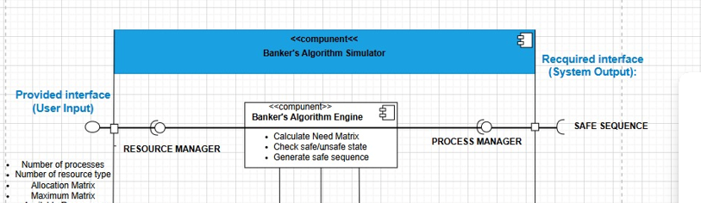

2.1.2 Banker’s Algorithm Engine (Core Processing Component)
This is the heart of the system.
This is the core component of the system. The Banker’s Algorithm Engine checks whether processes can execute based on available resources. The Safety Check module verifies whether all processes can complete successfully. If all processes finish execution, the system is considered safe; otherwise, it is unsafe.
Responsibilities:
- Calculate Need Matrix
Need=Maximum−AllocationNeed = Maximum - AllocationNeed=Maximum−Allocation
- Check Safe / Unsafe State
  - Simulates resource allocation
  - Determines if system can avoid deadlock
- Generate Safe Sequence
  - If safe → produces execution order of processes
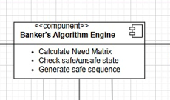

2.1.3 Supporting Components
- Resource Manager
Purpose:
Manages all resource-related data.
Handles:
- Allocation Matrix
- Maximum Matrix
- Available Resources
Role in System:
- Supplies data to the Banker’s Algorithm Engine
- Updates available resources during simulation

- Process Manager
Purpose:
Manages process-related information.
Handles:
- Process ID
- Execution Order
Role:
- Receives safe sequence from engine
- Organizes process execution order
- Displays ordered processes
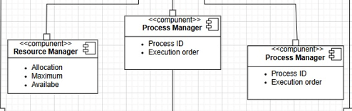

2.1.4 Deadlock Detector:
After applying the algorithm, the system determines whether it is in a safe or unsafe state. The Result Analysis component displays the Safe Sequence, final available resources, and system state.
Purpose:
Handles unsafe situations.
Responsibilities:
- Detect Unsafe State
- Display Error Message
- Inform system when no safe sequence exists
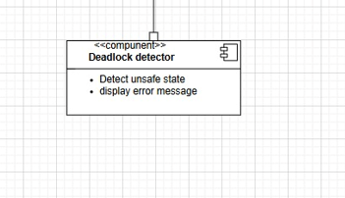

2.1.5 Interfaces:
- Provided Interfaces (User Input):
The User Interface collects process and resource data from the user including Allocation, Maximum, and Available resources.
User supplies:
- Number of Processes
- Number of Resource Types
- Allocation Matrix
- Maximum Matrix
- Available Resources
These inputs are sent to:
- Resource Manager
- Banker’s Algorithm Engine
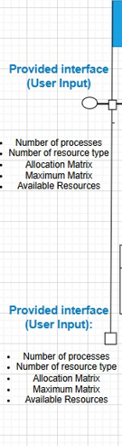
- Required Interfaces (System Output):
System produces:
- Safe Sequence
- Safe / Unsafe State
- Safe Sequence of Processes
These are returned to the user.
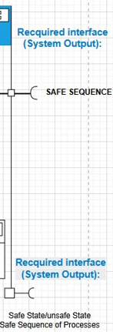

2.2 Data Flow:
Here is the complete flow of how data moves through the system:

Step 1: User Input:
User enters:
- Process count
- Resource types
- Allocation matrix
- Maximum matrix
- Available resources
Data is sent to Resource Manager

Step 2: Resource Preparation:
Resource Manager:
- Stores Allocation
- Stores Maximum
- Stores Available
- Sends data to Banker’s Algorithm Engine

Step 3: Need Matrix Calculation:
Banker’s Algorithm Engine:
- Computes:
Need=Maximum− AllocationNeed = Maximum –AllocationNeed=Maximum−Allocation

Step 4: Safety Check Simulation:
Engine:
- Uses Available + Need
- Simulates process execution
- Temporarily releases resources
- Checks if all processes can finish

Step 5: If SAFE:
Engine:
- Generates Safe Sequence (e.g., P1 → P3 → P0 → P2)
Sent to Process Manager
Displayed to User
If UNSAFE:
Engine:
- Signals Deadlock Detector
Deadlock Detector:
    - Displays "Unsafe State"
    - Shows error message
- Service-oriented internal modules

Logical View of System Flow:

User Input
↓
Resource Manager
↓
Banker’s Algorithm Engine
↓
[ Safe? ]
↓ Yes ↓ No
Process Manager Deadlock Detector
↓ ↓
Safe Sequence Unsafe Message
↓ ↓
User Output User Output

Component Architectural Diagram:
This diagram represents the complete integrated architecture of the Banker’s Algorithm Simulator. The overall flow begins from the User Interface, moves to Resource Management, then to the Banker’s Algorithm Engine, followed by Safety Check, Result Analysis, and finally Export Module. This structured design ensures modularity, clarity, and ease of future enhancement.
  - Conclusion:
The Banker’s Algorithm Simulator is designed using a modular component-based architecture to ensure clarity and efficiency. The system includes key components such as Resource Manager, Banker’s Algorithm Engine, Process Manager, and Deadlock Detector, each performing a specific function.
The simulator collects user input, calculates the Need matrix, checks system safety, and generates a safe sequence if possible. In case of an unsafe state, it detects potential deadlock and displays an appropriate message.
Overall, the design effectively implements the concept of deadlock avoidance in a structured and educational manner, making the system easy to understand, maintain, and enhance in the future.
